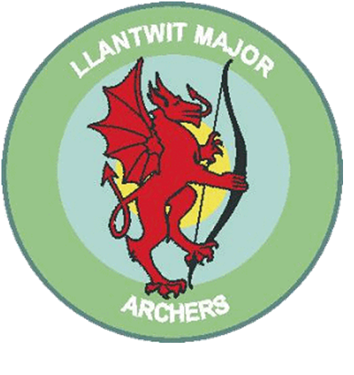
Llantwit Major Archery club

Beanies & Baseball Hats £7.50 each
Baseball Hats & Beanies in black, embroidered with either Llantwit Major Archers Club logo or Llantwit Major Junior Archers Club logo, please specify which badge you require on you order form below.

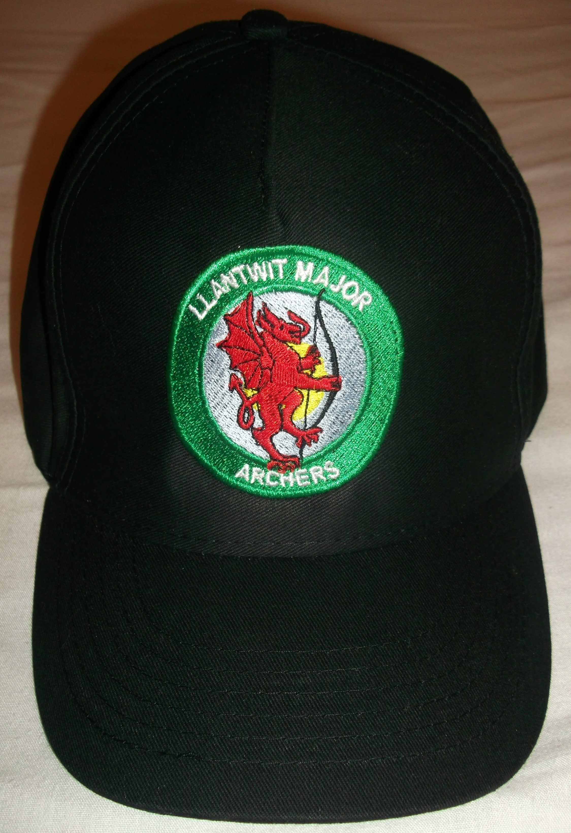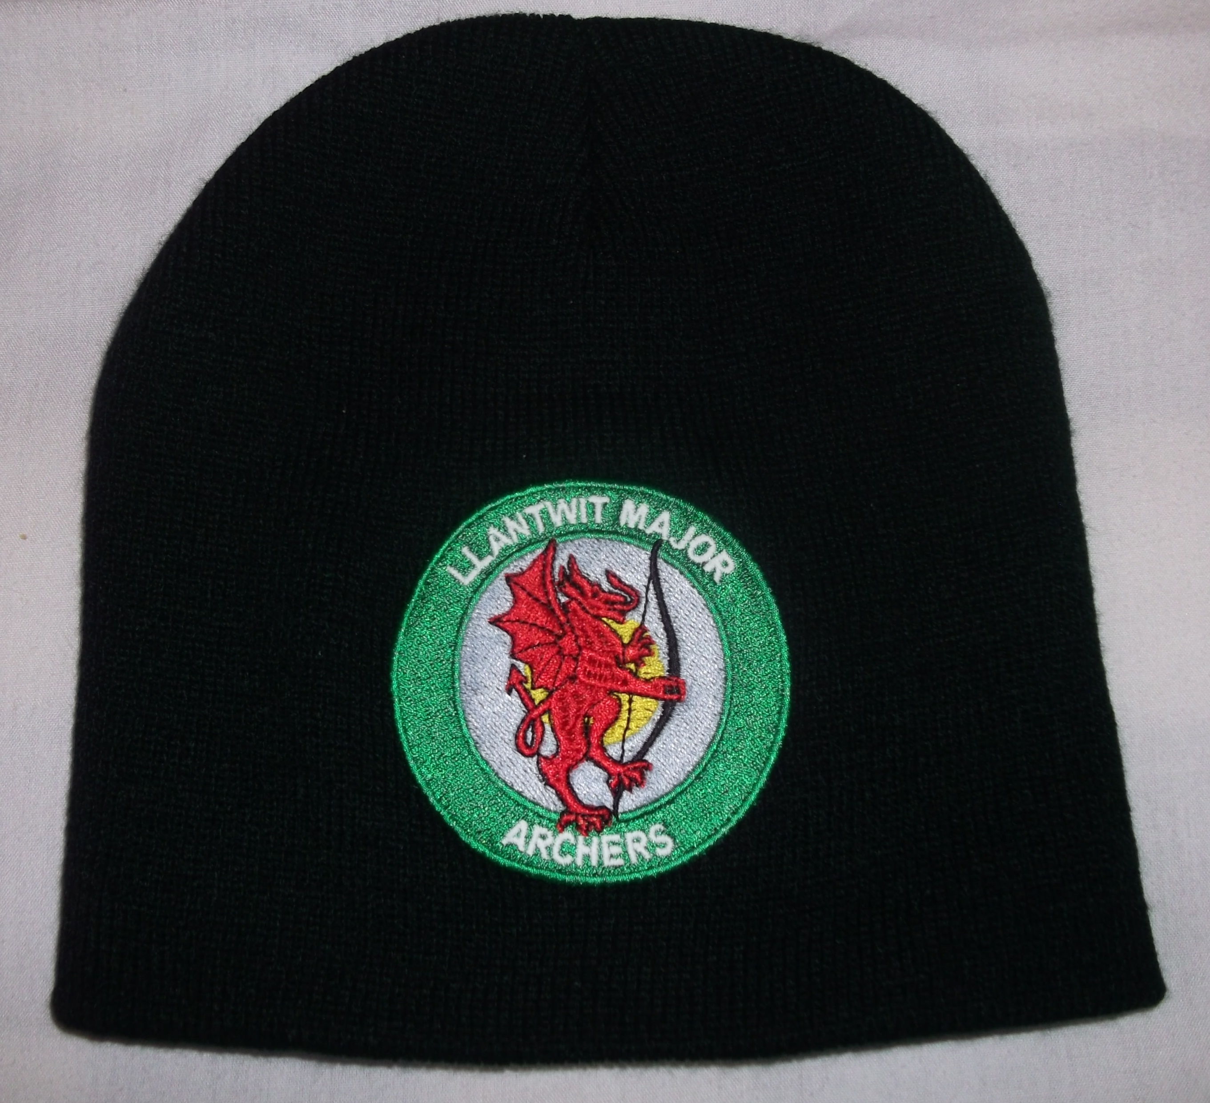

Order Name
Item |  | Qty | Cost
Baseball Hat With Adult Badge
Baseball Hat With Junior Badge
Beanie With Adult Badge
Beanie With Junior Badge
 |  | Total

Please make cheques payable to Llantwit Major Archery Club

